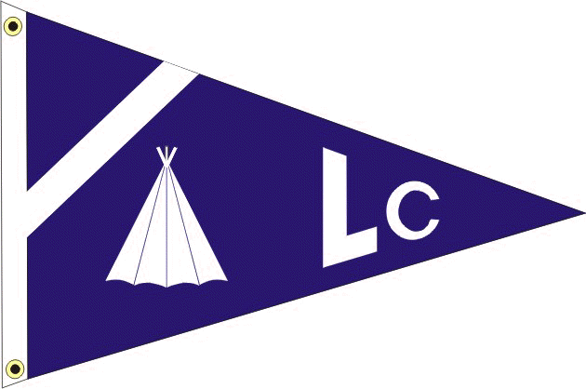 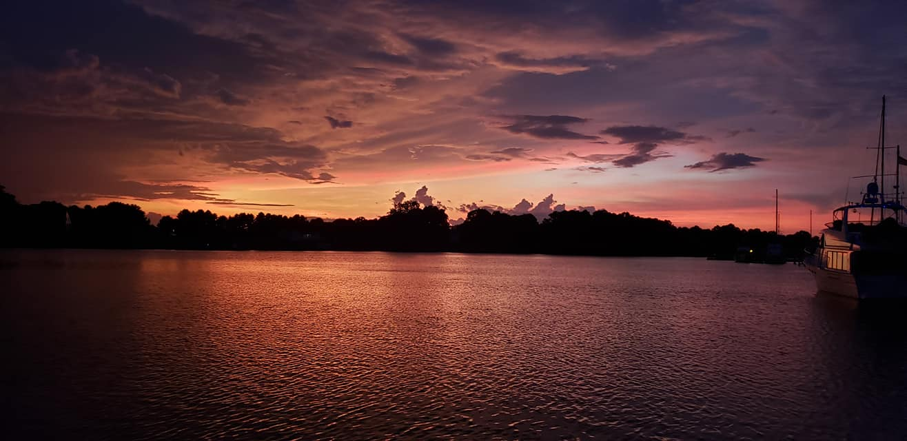 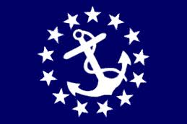

LODGE CREEK YACHT CLUB

may 2024 - newsletter

**___________________________________________________________________________________________________________**

**___________________________________________________________________________________________________________**

**2024 BRIDGE**

Commodore - Bobby Andrade

Vice Commodore - Rich Verdillo

Immediate Past Commodore - Antonia DePascale

Secretary - Theresa Sullivan

Treasurer - Jayne Miller

Fleet Captain - Heath Mullins

Ship Store - Lori Rappa

A-Dock Director - Ann Eichenmuller

B-Dock Director - Sue Eller

C-Dock Director - Laura Henson

D-Dock Director - Jamie Mullins

E-Dock Director - Bill Sullivan

Webmaster - Kenny DePascale

###### https://d2q0qd5iz04n9u.cloudfront.net/_ssl/proxy.php/http/gallery.mailchimp.com/f34cef74bdcbe5b4f9c5759bb/images/Comm.png Commodore: BOBBY ANDRADE

Hey Y’all “LCYC members “

Big shout out to our B Dock director and her team for putting together an excellent Cheeseburger in Paradise function! Even the weather cooperated.

Already mid-June and I finally lost my socks “yea 80’s”.

Next up C Dock’s function on June 22nd!

I spoke with Barbara from the PRYCA about their Float-In at Cole’s Point Marina the last weekend in June. Sign up ends on the 6/24. Check your LCYC website for details looks like will be a great event!

Thanks,

Bobby Andrade Jr., Commodore at Large 

###### vice commodore: RICH VERDILLO

I don't know about you, but I have had Jimmy Buffet songs in my head since the B Dock function. What a great time that was! I'm really looking forward to C Docks low country boil (my mouth just started watering!) on the 22nd. Boating season is in full swing so let's get to the marina and, to quote Hedley Lamar," Do that voodoo that you do so well." See you on the docks!  
  
Vice Commodore

Rich Verdillo

###### TREASURER: JAYNE MILLER

Thanks to B Dock for their work on a fun event in May! We had 67 people in attendance. Please remember to respond to the RSVP emails to help with the amount of food to be prepared. They spent $908.92 on food and drink and raised $302 in guest fees, 50/50, and their raffle. They also spent $44.97 purchasing paper products for the supply closet. Great job on staying below budget! =

Jayne Miller, Treasurer

**FROM YOUR DOCK DIRECTORS**

A DOCK DIRECTOR: ANN EICHENMULLER

We are planning our A Dock Function on August 17, 2024. We are planning on having a catered main dish, which will be a Southern BBQ. Keep an eye out for the invite! Hope to see you all there!

Ann Eichenmuller

A Dock Director

B DOCK DIRECTOR: SUE ELLER

Thanks to all who came out to enjoy our May “ Cheeseburger in Paradise” party. Good food, great margaritas, fun music and yummy key lime pie; along with all our friends made for a wonderful evening.  Grateful for all my fellow B  dockers who helped make it such a success. It takes many hands to host a yacht club function so a big thanks for all those who pitched in.  Looking forward to our next get together. See you on the docks!

Sue Eller

B Dock Director

C DOCK DIRECTOR: LAURA HENSON

To all C dock crew: we are gathering together on the C dock for brunch at 10:00 am Sunday, June 23rd.

Bring a dish to share & a chair if you have one.

Laura Henson

C Dock Director

**MESSAGE FROM OUR PRYCA DELEGATE - STEVE THOMPSON**

Now that summer is underway, it’s time for the PRYCA (Potomac River Yacht Club Association) Float-In at Coles Point. I encourage all boaters to log onto the Eventbrite Link on our website to see what this is all about and the vast number of activities this weekend presents. The dates are June 28-30 and for anyone located at OLCM

As of now, we do not have anyone registered from our Club. I know we are all busy with other things going on, but anything we can do to support the PRYCA would be great. They have attended many of our events.

Coles Point is a very short run by water up the Potomac and also a short distance by road. It’s a fun event and also a great way to get to know fellow boaters in our surrounding area.

Steve Thompson

PRYCA Delegate OLCM

**MESSAGE FROM DAVE TEETS - SAFETY OFFICER**

**BOATERS SAFE BOATING COURSE**  - Effective July 1, 2019 all Virginia boaters must have taken a Certified Boaters Safe Boating Course and have proof of this while boating in Virginia waters while operating any vessel powered by a motor of at least 10 hoursepower. This law makes no distinction of age or experience.

As we start the boating season, we must all renew our commitment for SAFE BOATING.

**Spring Virginia Safe Boating Class**

**Saturday, June 15, 2024**

If you are planning on operating a boat in Virginia waters that is 10hp or more, you are required to have taken a certified Boater Safety Course. Lodge Creek Yacht Club and Olverson’s Marina sponsor this one-day class and **it’s free!!!**

This 8-hour class will be offered on Saturday June 15, 2024 and comes with a lunch that is provided by the Marina! So, the class is free, and lunch is too!!

If you are operating a boat in Virginia waters, you are supposed to have a copy of your Boater Certification Card with you. If you don’t have it with you, Law Enforcement will ruin your day!!

Mark this date on your calendar, and plan on attending the class. Don’t forget the kids and grandkids who may be old enough to operate a boat, but don’t have the certification. Be sure that you contact the Marina Office to sign up for the class.

**VESSEL SAFETY CHECKS** - The most cautious boaters can sometimes experience unexpected problems on the water. That's why the U.S. Coast Guard recommends that all recreational boaters, including personal watercraft and paddle sport users take advantage of the free Vessel Safety Check Program every year.

Remember, try to obtain a VSC exam before the boating  to help insure your safety throughout the boating season.  These examiners provide a lot of useful information and can help you with many of your boating questions also!!!

**What’s in it for me??**

Vessels passing safety checks are awarded a U.S. Coast Guard Decal that informs all law enforcement agencies that your boat was in full compliance with all Federal and State boating laws during a safety check for a particular year. Best of all…its free of charge!!

**Why Receive a Vessel Safety Check??**

Safety!! The peace of mind that your boat meets federal safety standards and that in an emergency you will have the necessary equipment to save lives and summon help!

**Where do I get a Vessel Safety Check?**

All those who are at Olverson’s Marina are eligible for a Vessel Safety Check. There are two certified examiners located at the Marina and are available for a VSC. Jim Zeigler and Dave Teets are certified examiners and are members of Lodge Creek Yacht Club as well. While their boats are located on C-Dock, feel free to call them or let them know you want one. Their information is located in the LCYC Directory.

**How long does it take?**

Generally, the Vessel Safety Check takes about 20 minutes and if your boat passes, then you are awarded the VSC sticker immediately and it is valid for the rest of the calendar year.

**The new 2024 VSC stickers should be available in late January, so be sure to put this project on your “to do” list for the new boating season!!**

Dave Teets

Past Commodore/Safety Officer

_______________________________________________________________________________________

***IMPORTANT INFORMATION TO REMEMBER***

**MEMBERSHIP RENEWAL**

**THE FISCAL YEAR FOR LCYC RUNS FROM DECEMBER 1ST THRU NOVEMBER 30TH OF THE FOLLOWING YEAR.**

Dues renewal forms are due **December** **1st** and collected thru **January 31st**, without a penalty fee.  Renewals paid after the that date are subject to a late fee of $20 and are payable for the next 60 days.  After that date per Article V, Section 3D, failure of payment is construed as resignation of membership and I am required to notify the ex-member in writing of the termination.  Per Section 3F, payment of delinquent dues and a reinstatement fee equal to 1/3 of the annual dues made by the ex-member and the acceptance of and reinstatement shall be the sole discretion of the Board of Directors and decided by a majority vote.

An invoice is **not** sent for the dues collection, the Secretary has graciously sent reminders with an attachment of the renewal form for your convenience prior to the due date of December 1 and often a second reminder prior to the January 31 date.  The renewal form can also be found on our website.

**LCYC Website link**: [https://www.lodgecreekyachtclub.com](https://www.lodgecreekyachtclub.com/). For quick access to the Roster and dock assignments the link is: <http://www.lodgecreekyachtclub.com/members/>  (Password Protected) You do not need to make your own password. Please reach out to Theresa at theresasullivan6188@gmail.com if you need the password or to me at [webmaster@lodgecreekyachtclub.com](mailto:webmaster@lodgecreekyachtclub.com).

-Kenny D, LCYC Webmaster